**STANDARDS**

Standard is a document established by consensus and approved by a recognized body that provides for common and repeated use, rules, guidelines or characteristics of activities or their results aimed at achieving the optimum degree of order in a given context.



Contain the technical and other requirements that products and services have to comply with, either voluntary/compulsory, through contract or by regulation.

Standards are applicable to production and service processes and to the outcome of those processes, products and services.



Standards have hierarchy: International, Regional and National standard bodies. The standard is published in a variety of ways, e.g. hard copy, electronic, etc.



The developed standards are implemented in the manufacturing industries and service providing organizations to improve product and service qualities.



**METROLOGY**

Metrology is the science of measurement embracing both experimental and theoretical determinations at any level of uncertainty in any field of science and technology.

Essential to all aspects of human life, as they are applied starting from production control, protection of the environment, and protection of the safety and health of the people, testing of quality of products and ensuring fair trade for consumer protection. Metrology is a very broad field and may be divided into three subfields.

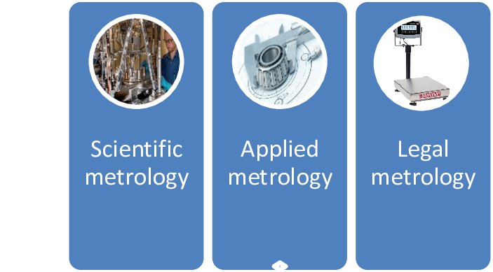

**Scientific or fundamental metrology**

Scientific metrology is concern the establishment of quantity systems, unit systems, and units of measurement, the development of new measurement methods, realization of measurement standards and the transfer of traceability from these standards to users in society.

 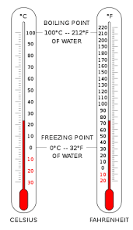

**Applied or industrial metrology**

Applied or industrial metrologyis concern the application of measurement science to manufacturing and other processes and their use in society, ensuring the suitability of measurement instruments, their calibration and quality control of measurements.

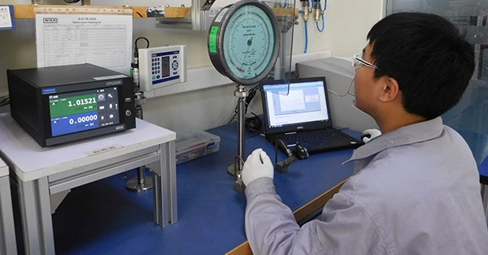

**Legal metrology**

Legal metrology is concern regulatory requirements of measurements and measuring instruments for the protection of health, public safety, the environment, enabling taxation, protection of consumers and fair trade.



